Transforming Traffic in Pima County:
Cutting-Edge Solutions and Key Infrastructure Projects Improving Traffic Congestion
By: Anthony J. Herrera, PE
Traffic congestion is a significant challenge in urban areas, and Pima County, Arizona, is no exception. As the population grows and economic activities expand, the existing road infrastructure often struggles to accommodate the increasing number of vehicles. To address this issue, Pima County has implemented various innovative solutions and strategic projects aimed at improving traffic flow and reducing bottlenecks.
Tucson, the heart of Pima County, and the rapidly growing town of Marana face significant traffic congestion challenges. Major arterial roads and intersections in Tucson experience severe delays during peak hours, disrupting daily commutes and local businesses. Similarly, Marana's key roads, especially those linking residential areas to commercial centers, are frequently congested due to the town's rapid growth, underscoring the urgent need for strategic infrastructure interventions.
The Role of Road Widening
Widening roads by adding additional lanes increases the capacity to handle more vehicles, helping to alleviate constrictions and ensure smoother traffic flow. This approach also enhances safety by including dedicated lanes for turning, cycling, and emergency vehicles, thereby reducing the likelihood of accidents. Moreover, road widening projects often incorporate modern design standards and future-proofing elements, ensuring that infrastructure can accommodate future growth and technological advancements.
Twin Peaks, Rattlesnake Pass Widening Project
The Twin Peaks, Rattlesnake Pass Widening Project focuses on widening Twin Peaks Road at Rattlesnake Pass to improve traffic flow and safety.
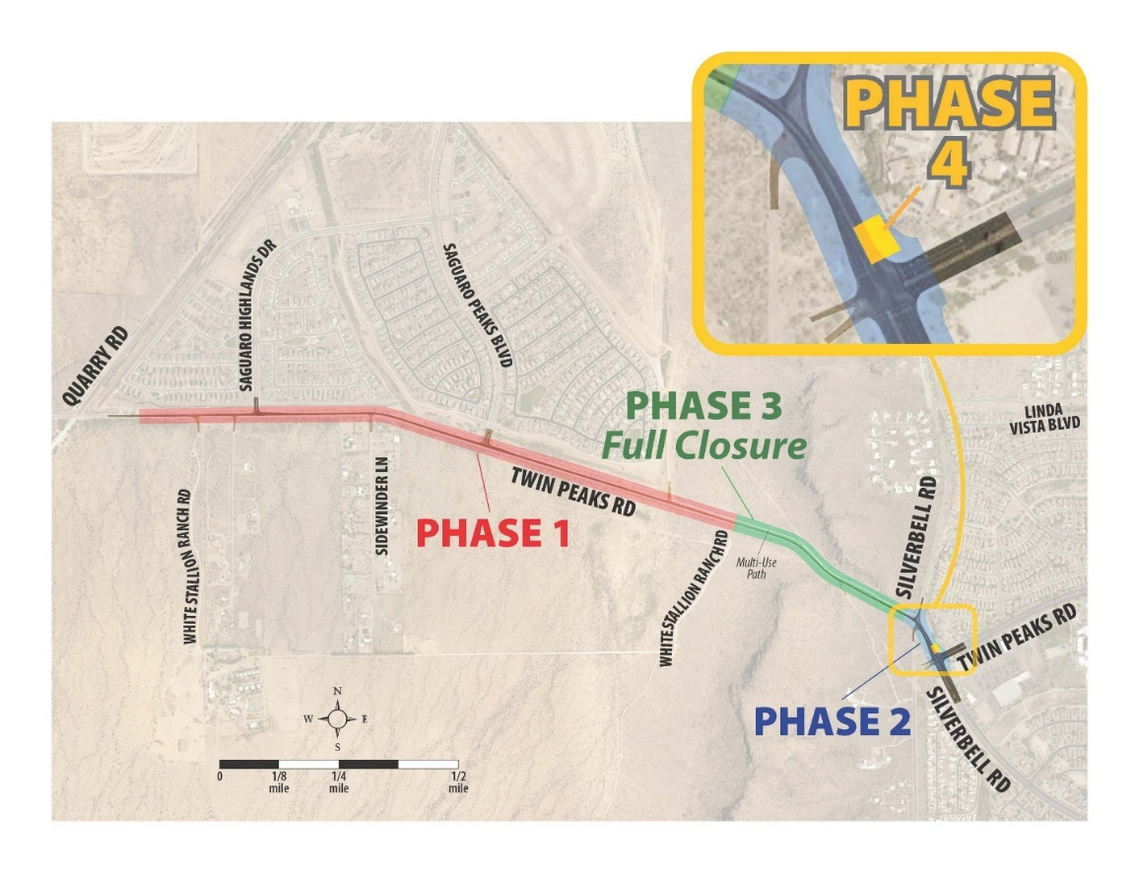
This project includes several key improvements: new traffic signals at the Twin Peaks/Saguaro Peaks and Twin Peaks/Silverbell intersections, a new east and westbound dual lane roadway with a median, storm drain structures, irrigation and landscaping, curbs and sidewalks, ADA access ramps, stormwater catch basins, and a multi-use path extending from White Stallion Ranch Road to Old Silverbell Road. Additionally, underground utility improvements and relocations were completed ahead of the roadway construction, and a new slope retainment wall with architectural treatment will be installed through the pass.
The major benefit to the public of the Twin Peaks/Rattlesnake Pass widening project is the significant improvement in traffic flow and safety. By adding new traffic signals, dual lane roadways, and dedicated pedestrian and cycling paths, the project will alleviate congestion, reduce travel times, and enhance overall road safety. Additionally, the inclusion of ADA access ramps and improved stormwater management will contribute to a more accessible and resilient infrastructure, benefiting all road users.
Construction began in July 2024 and will run through August 2026.
New and Improved Interchanges
Pima County Department of Transportation, in collaboration with the Arizona Department of Transportation (ADOT), has initiated several interchange projects aimed at improving traffic flow, reducing congestion, and enhancing road safety.
The I-10/Ruthrauff Road Interchange Project
The I-10/Ruthrauff Road interchange has been one of the most congested areas in Pima County. Located in a busy commercial zone with a high volume of both local and through traffic, the existing interchange structure was outdated and insufficient to handle the growing traffic demands.
The I-10/Ruthrauff Road interchange project aimed to reduce traffic congestion by improving traffic flow on both I-10 and Ruthrauff Road through an upgraded interchange design. It also focused on enhancing safety with better lane transitions, clearer signage, and safer pedestrian crossings. Additionally, the project was designed to accommodate future growth by constructing an interchange capable of handling projected traffic increases over the coming decades.
Since the completion of the I-10/Ruthrauff Road interchange project, there has been a noticeable improvement in traffic flow, with reduced congestion during peak hours. Enhanced safety has also been achieved, as the number of traffic accidents in the area has decreased due to better road design and clearer signage. Additionally, the inclusion of pedestrian and cyclist infrastructure has made the area safer for non-vehicular traffic. The improved interchange has facilitated better access to local businesses, potentially boosting the local economy by making the area more attractive to both customers and investors.
EPS Transforms Tucson’s Transportation
Valencia Road Widening Project Earns Top Honors
for Reducing Congestion and Enhancing Safety
The Valencia Road and Kolb Road Intersection project in Tucson was a finalist for the 2019 Metropolitan Pima Alliance Common Ground Award and APWA, Arizona Chapter Southern Branch – 2020 Project of the Year, Transportation ($5-$25 million range).
Valencia Road is a critical east-west arterial road in Pima County, serving as a major thoroughfare for both local and regional traffic. Over the years, the road has experienced significant congestion, particularly during peak hours, due to rapid residential and commercial development in the surrounding areas. The existing two-lane road was no longer sufficient to handle the increasing traffic volumes, necessitating a comprehensive upgrade.
The primary objectives of the Valencia Road Widening Project were:
- Reduce traffic congestion: Expand Valencia Road from two lanes to four lanes to improve traffic flow and reduce delays, particularly during peak travel times.
- Enhance safety: Upgrade road design features, including the addition of dedicated turn lanes, improved signage, and pedestrian/bicycle pathways to enhance overall road safety.
- Accommodate future growth: Design and construct infrastructure that can support projected increases in traffic and development in the area over the coming decades.
EPS Group, Inc. was responsible for the comprehensive engineering design and planning of the Valencia Road widening project. Our work included detailed roadway design, traffic analysis, drainage solutions, and utility coordination. EPS employed advanced modeling techniques to ensure that the road expansion would effectively manage current traffic volumes while accommodating future growth.
One of the key contributions of EPS was the implementation of traffic and safety improvements. This included designing new traffic signals, optimizing intersections, and creating safer pedestrian crossings. EPS Group, Inc. also integrated dedicated bicycle lanes and sidewalks, promoting safer and more accessible routes for non-vehicular traffic.
The widening of Valencia Road from two lanes to four lanes has significantly improved traffic flow in the area, leading to reduced travel times for commuters, especially during peak hours, and contributing to a more efficient transportation network. This project has also substantially enhanced road safety through the addition of turn lanes, improved signage, and dedicated pedestrian and bicycle pathways, resulting in fewer traffic incidents and safer conditions for all users. The upgraded Valencia Road is now better equipped to handle the expected regional growth, with expanded capacity and infrastructure that support ongoing residential and commercial development, making the area more attractive to investors and new residents. The successful completion of the project has been well-received by the community, as it has not only alleviated congestion but also enhanced the overall quality of life for residents by providing safer and more efficient transportation options.
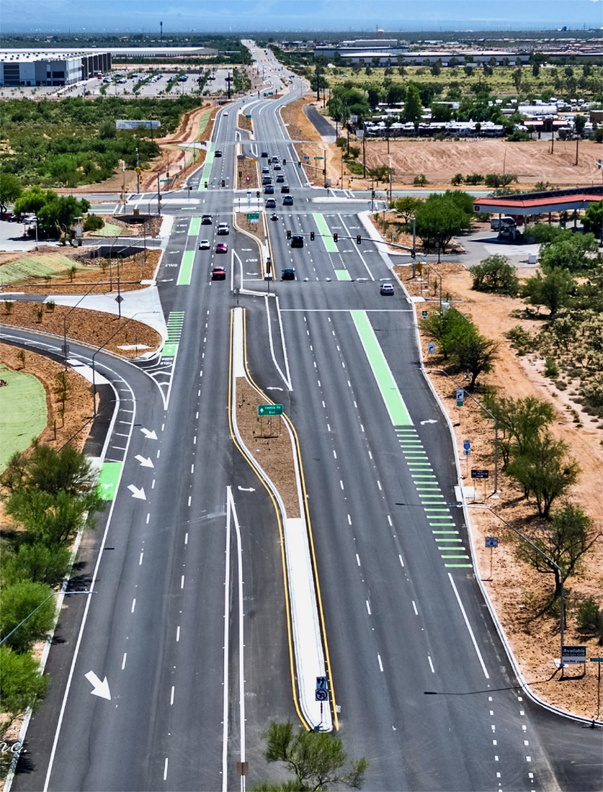

Traffic congestion remains a pressing issue in Pima County, Arizona. Road widening projects, like the Rattlesnake Pass Widening Project and Valencia Road Improvement Project, offer practical solutions to enhance traffic flow, improve safety, and support future growth. By investing in strategic infrastructure improvements and engaging the community, Pima County can create a more efficient and sustainable transportation system.
EPS Group: Your Partner in Traffic Congestion Solutions
At EPS Group, we elevate Arizona’s public works departments. Since 2003, we have been a trusted industry leader, committed to improving the communities we serve. With over 300 professionals, we excel in multi-disciplinary land and infrastructure development, making us a reliable choice for high-quality public works projects.
Choosing EPS Group means partnering with a firm that puts people first, ensuring your public works initiatives succeed. We offer integrated and efficient solutions for complex projects, understanding the unique challenges of Arizona's rapidly growing counties and municipalities.
For public agencies across Arizona, this means meeting deadlines, managing budgets, and achieving project success. Together, we can make a lasting impact on Arizona’s public works landscape.

EPS Group is known for delivering effective solutions to alleviate traffic congestion. We specialize in expanding and optimizing road networks to enhance traffic flow. Our portfolio includes successful projects that reduce urban congestion, offering comprehensive services from planning and design to construction management.

Our approach focuses on addressing traffic congestion by actively engaging local residents and stakeholders through public meetings, surveys, and workshops, ensuring solutions meet community needs. We incorporate the latest technologies and sustainable practices into our designs, prioritizing safety with features like optimized traffic flow, improved road signage, and enhanced intersection designs.

If you’re a public service professional, we salute you. No public agency is immune to aging infrastructure, rising costs, or limited resources. As your engineering partner, we help you do more with less, offering efficiency through a multi-discipline, Arizona-based team that understands local nuances.

------------------------------------------------
Anthony J. Herrera, PE is a Principal and Public Works Manager at EPS. Anthony has 21 years of experience in construction and engineering design. He has designed, managed, or coordinated projects with several jurisdictions in Arizona including ADOT, Pima County, City of Tucson, Town of Marana, Pinal County, City of Maricopa, City of Casa Grande, Yuma County, and the City of Yuma.
-----------------------------------------------

Resources and Further Information
- EPS Group (insert active landing page link)
- Pima Association of Governments
- Regional Transportation Authority

